# Data Structures and Algorithms

This document details how to learn data structures and algorithms

# Determine Data Structure or Algorithm to Learn

In this step, you will simply select a data structure or algorithm you want to learn. A good place to start if the books collection or the data structures and algorithms specialization.

# For Each Data Structure or Algorithm

For example, if you selected LinkedList

1. Select 1 of the following 4 programming languages
   1. Python
   2. JavaScript
   3. Java
   4. C#
2. Watch videos on what a linked list is
3. Determine the operations the linked list supports
4. Create a skeleton class that implements the linked list and all operations. This class should not implement any functionality yet.
5. Create a series of unit tests on the class to test whether all supported operations.
   1. Implement edge and corner cases such as passing null references, passing empty lists, passing objects that the class does not expect (for example pass a number where a string is expected).
   2. Implement stress test on the class and compare your code to code you stole from the internet. For example, a linked list implementation, your implementation should be coming back exactly as a valid implementation.
   3. Show the unit tests failing
6. Write pseudo code and comments for the implementation in the class
7. Run through the pseudo code in a memory model or memory diagram to figure out what will happen under the hood <https://www.youtube.com/watch?v=wAx2DgsHQg4>
8. Implement class for the linked list and show the unit tests passing.
9. Look for 1 additional question on the internet. For example, how to reverse a linked list.

# List of Data Structures and Algorithms

Data Structures

1. Queues Done
   1. Queue - Done
   2. Binary Heap - Done
      1. Max heap -Done
   3. Priority Queue Using Binary heap – Done All the same operations as binary max heap
2. Stack – Done in Java
3. Trees
   1. Binary Tree – Done in C#
   2. Trie – Done in python
   3. AVL Tree - skipped
   4. Splay Tree skipped
4. Heap – implemented binary heap in javascript
5. Stack – implemented stack in java
6. Disjoint Set – implemented in javascript
7. Hash Table
   1. Hash Function
   2. Distributed Hash Table
   3. Hash map
   4. Hash set
8. Graph

Algorithms

1. Rabin-Karp Algorithm
2. Heap sort
3. Graph algorithms
   1. Graph ordering - pre and post visit order
4. Directed Acyclic Graphs
5. Topological Sort
6. Strongly Connected Components
7. Most direct route in a graph
8. Breadth First Search
9. Shortest path tree
10. Dijkstra's Algorithm

## Queue (Completed)

<https://www.geeksforgeeks.org/queue-data-structure/>

Like [Stack](http://quiz.geeksforgeeks.org/stack-set-1/), [Queue](http://en.wikipedia.org/wiki/Queue_%28data_structure%29)is a linear structure which follows a particular order in which the operations are performed. The order is **F**irst **I**n **F**irst **O**ut (FIFO).  A good example of queue is any queue of consumers for a resource where the consumer that came first is served first.  
The difference between stacks and queues is in removing. In a stack we remove the item the most recently added; in a queue, we remove the item the least recently added.

**Operations on Queue:**  
Mainly the following four basic operations are performed on queue:

**Enqueue:**Adds an item to the queue. If the queue is full, then it is said to be an Overflow condition.  
**Dequeue:** Removes an item from the queue. The items are popped in the same order in which they are pushed. If the queue is empty, then it is said to be an Underflow condition.  
**Front:**Get the front item from queue.  
**Rear:** Get the last item from queue.

## Binary Max Heap – Done in Javascript

What is a Binary Max Heap

Maintain the following invariants

Use an array to implement to binary max heap.

Any new items will be added to the right most leaf in the tree.

If the item added is smaller or equal to parent, do nothing as invariant is maintained. If item added is larger, then sift up until it can’t be sifted up anymore.

Operations

GetMax – Only return the max

InsertNode - Insert Node into right most leaf in the tree and sift up

Extract Max – Extract the max item by replacing last bottom leaf (right most leaf) with the root and then cutting the max item. Then sift down the root node until it gets to the right place. Be sure that the function returns the new state of the array.

Change Priority – if priority is increasing, then check if the priority is higher than the parent. If it is, then sift up. If priority is decreasing, then siftdown.

Remove Element – Change the priority of the element to max plus 1. Sift up and then run extract max.

Sift up – get parent and if smaller then swap up

Get parent -

## Stack – Done implemented in Java

1. Push (key) – Adds the key to the collection and return the key
2. Top(): return most recently added key
3. Pop() remove and return most recently added key
4. Empty() return whether there are any elements in the stack

Problem

Implement bracket matching solution using a stack

[]{{()}} is balanced etc.

## Binary Search Tree

1. Create a simple hello world console application.
2. Create a binary search tree class, implement stub functions and import it in the console application.
3. Create a new instance of the BST class.
4. Create unit tests for all BST functions and show them failing

The following is the definition of Binary Search Tree(BST) according to [Wikipedia](http://en.wikipedia.org/wiki/Binary_search_tree)  
Binary Search Tree is a node-based binary tree data structure which has the following properties:

* The left subtree of a node contains only nodes with keys lesser than the node’s key.
* The right subtree of a node contains only nodes with keys greater than the node’s key.
* The left and right subtree each must also be a binary search tree.   
  There must be no duplicate nodes.

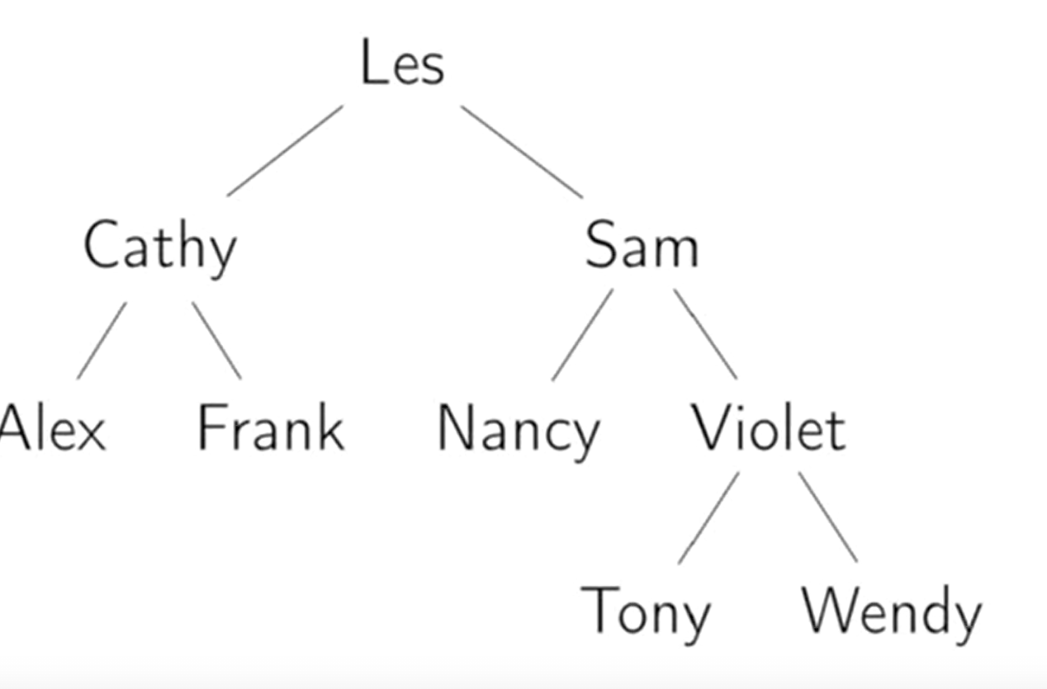

getHeight – Get the tree height.

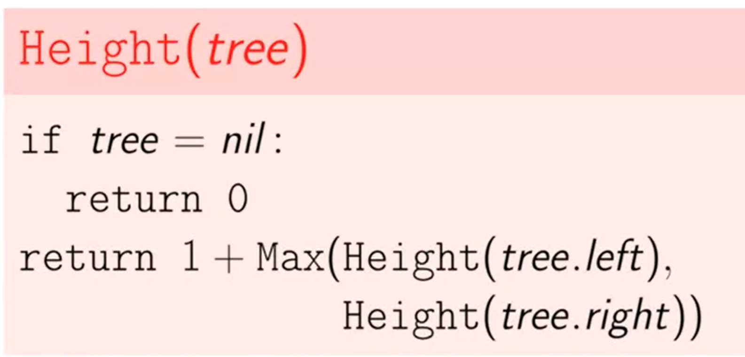

AddNode(value) – Traverse tree and add to a leaf

DeleteNode(value) – Tricky. Watch video again – Remove as last leaf is easy. Remove a node with one child is easy, just attach the child to the parent. In order to remove a node with two children, find the min in the right subtree of that node. That node will not have a left child. Replace the node value with the min node value and delete the one child min node.

NodeExists(value) – Similar algo as AddNode

BreadthFirstSearch –

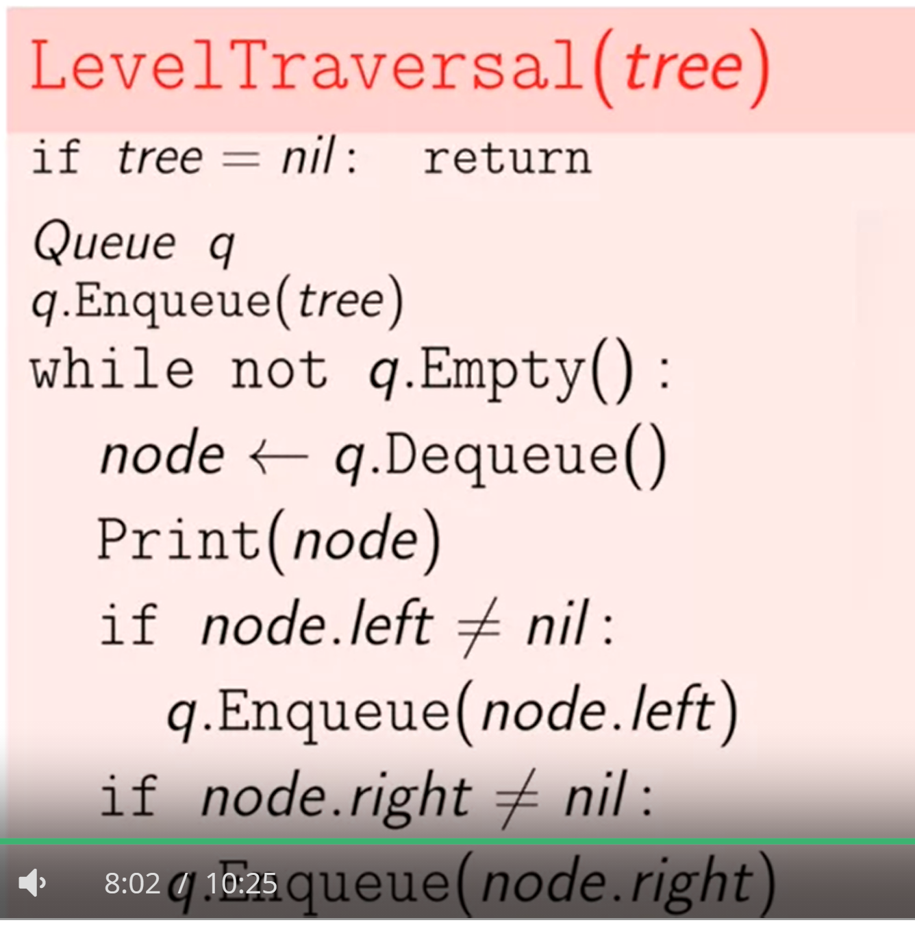

InOrderTraversal – Recursive Traversal of left first, then print node and the right child

PreOrderTraversal – Recursively visit the node, then the left tree, then the right tree.

PostOrderTraversal – Recursively visit the left tree, the right tree and then the node.

## Trie – Implemented in Python – Notes lost

## AVL Tree is in week 5 of data structure spec course - Skipped

1. Left child is less than parent. Right child is greater than or equal to parent. AVL tree is a binary search tree that is balanced.
2. Node contains the following
   1. Key
   2. Left Child
   3. Right child
   4. Height
3. Tree with no nodes has no height.
4. Tree with one node has 0 height and tree with a parent and child node has height 1
5. Recursive definition of height = 1 + Max(height of left, height of right) with basis condition being when the child is null return zero.  
   
6. An AVL tree, the height of the left subtree – height of the right subtree is at most 1. In mathematical term abs(height(L) – height(R)) = 1. If the left subtree is longer, then the tree is left heavy. If the right subtree is longer, then then its is right heavy. This property must hold at all nodes in the tree
7. Find(Key) – Find the key in the tree and return the node that has that key. K is the key.   
   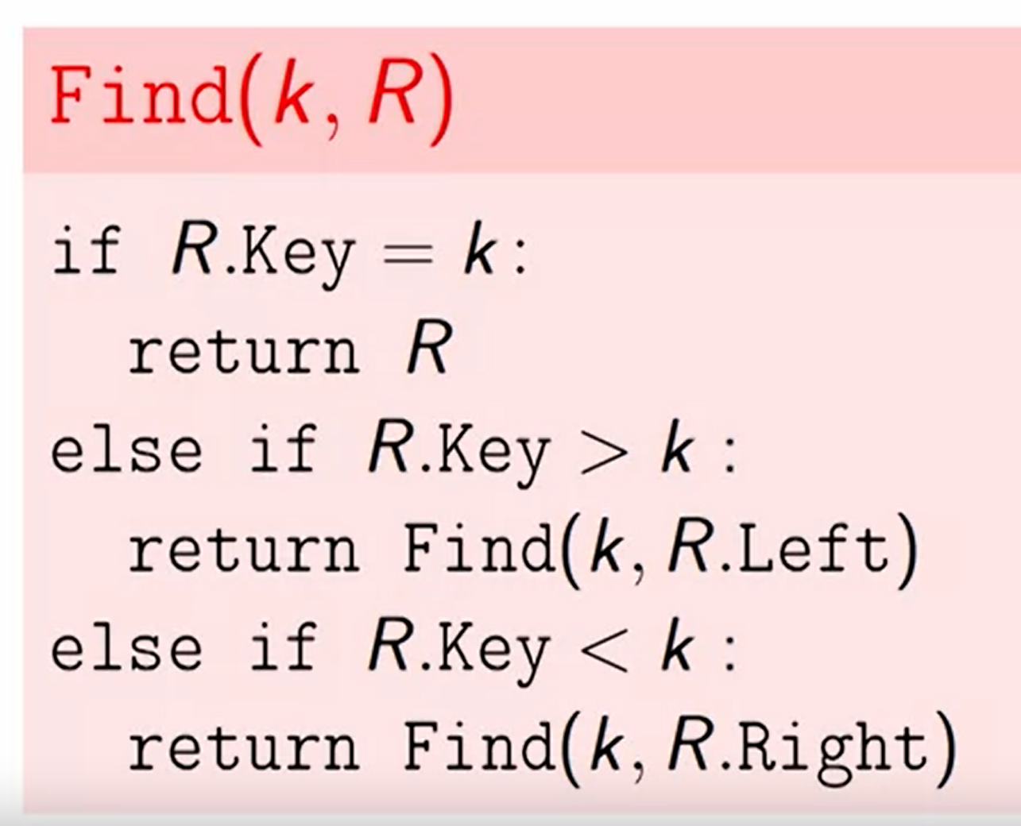
8. If however, the node is not in the tree, the find procedure the nearest node where the node should be inserted.  
   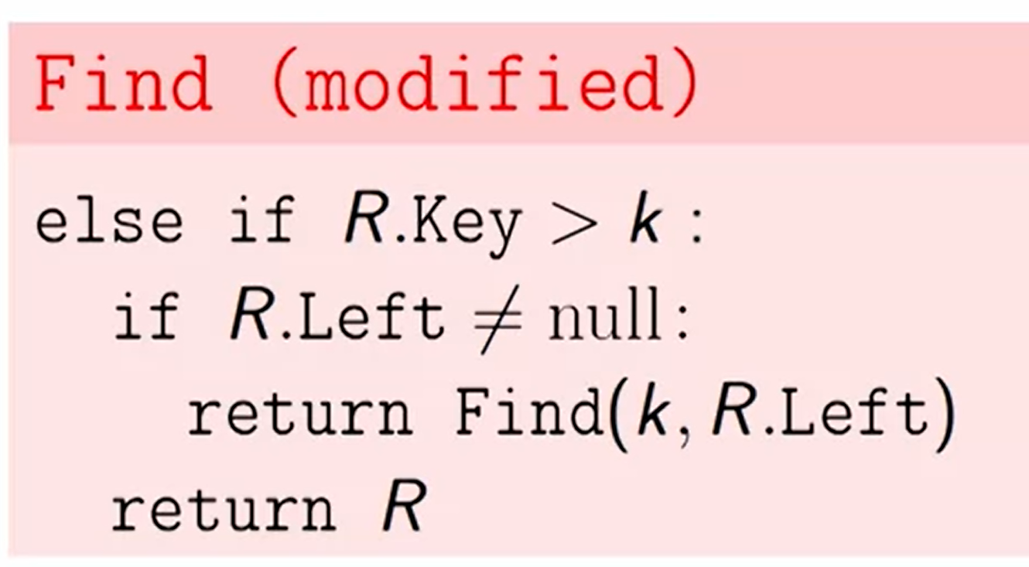
9. Next(key) – Find a node that has the next largest key. Start from the right subtree of the node and then keep going doing the left subtree of the right subtree to find the adjacent node. If node does not have a right subtree then return the next biggest parent.  
   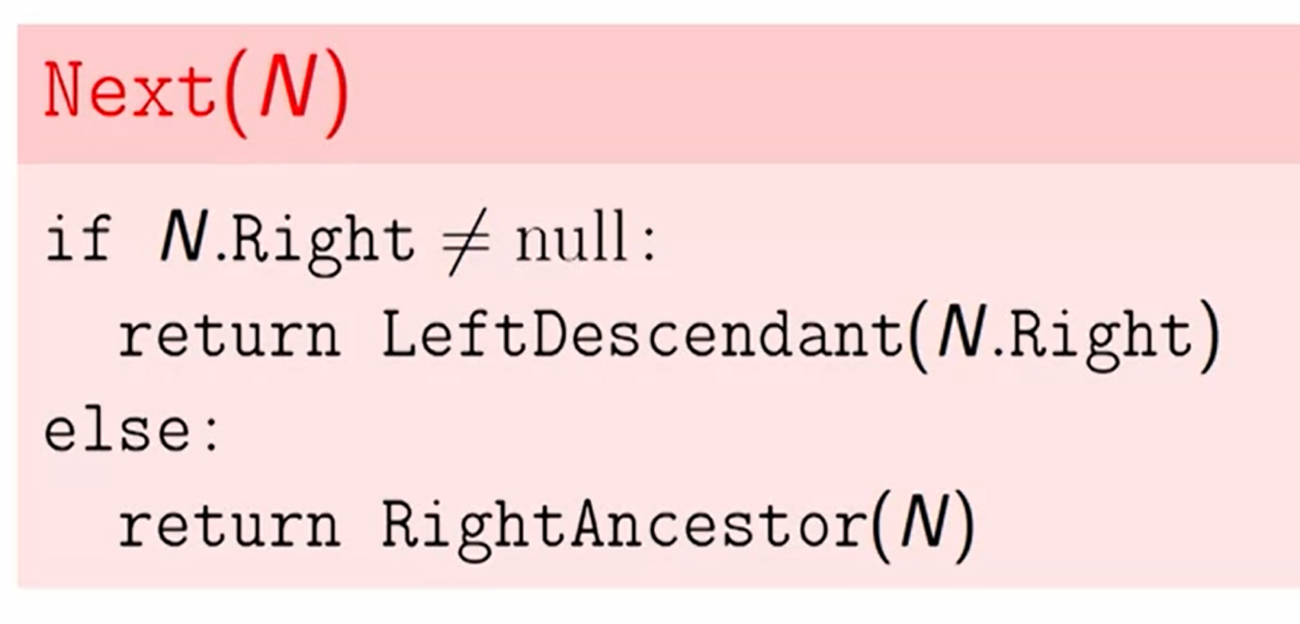  
   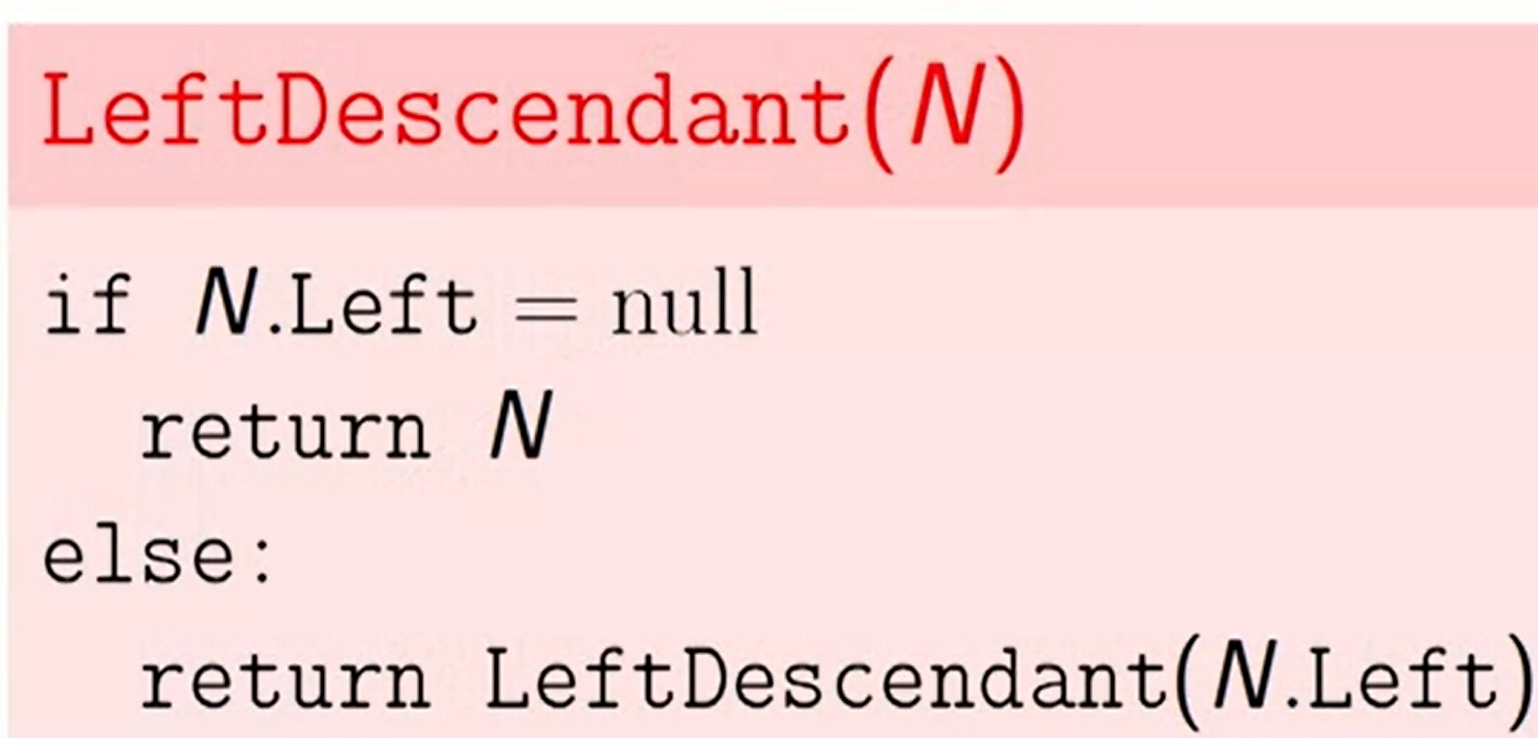  
   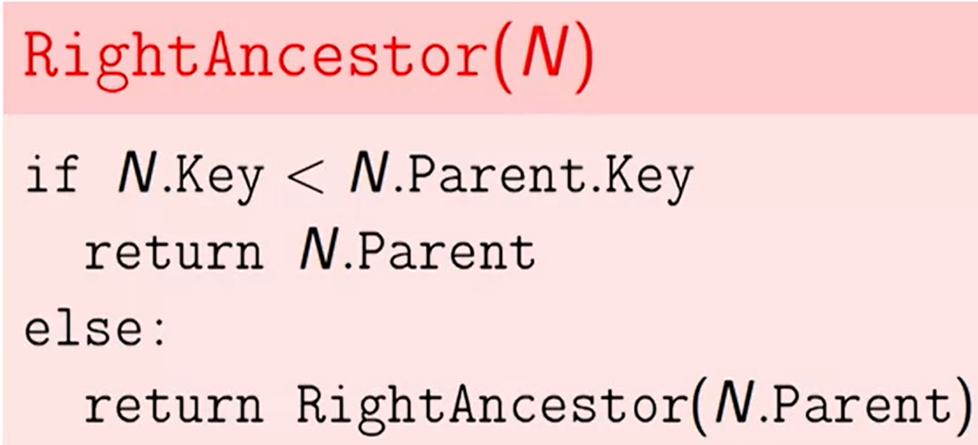
10. Insert – Use the find modified method to find the node where it ought to be inserted
11. AVLInsert  
    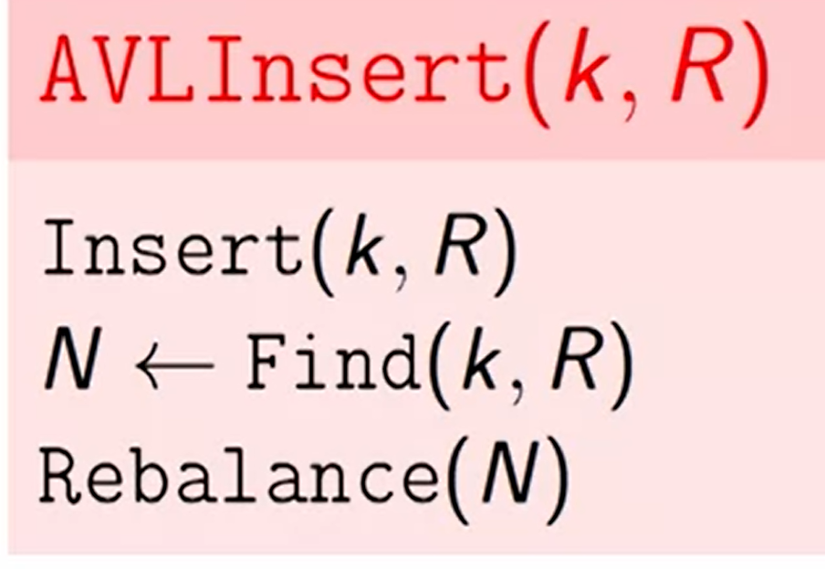  
    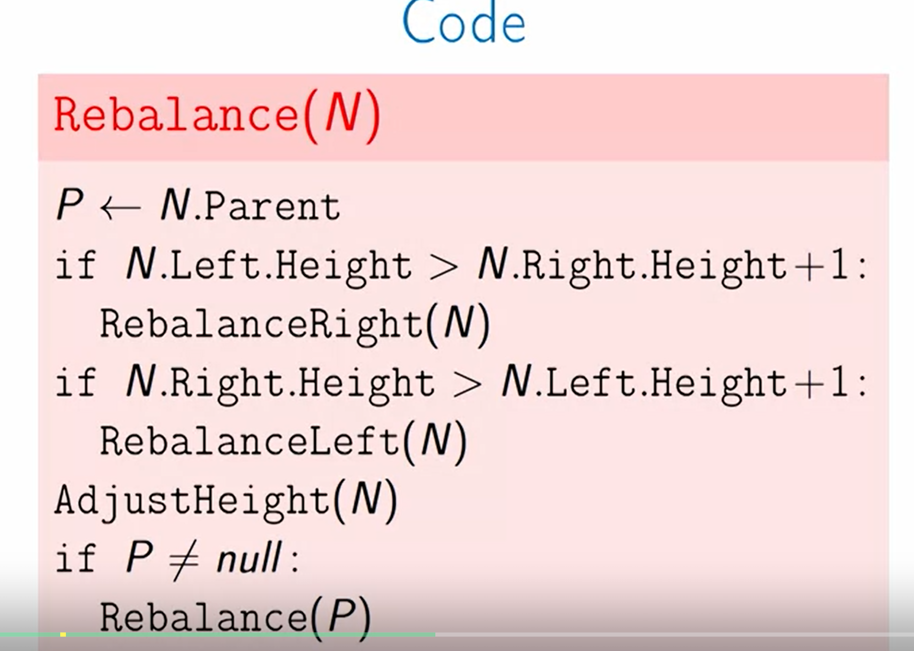

And then adjust heights on the insertion path of the tree  
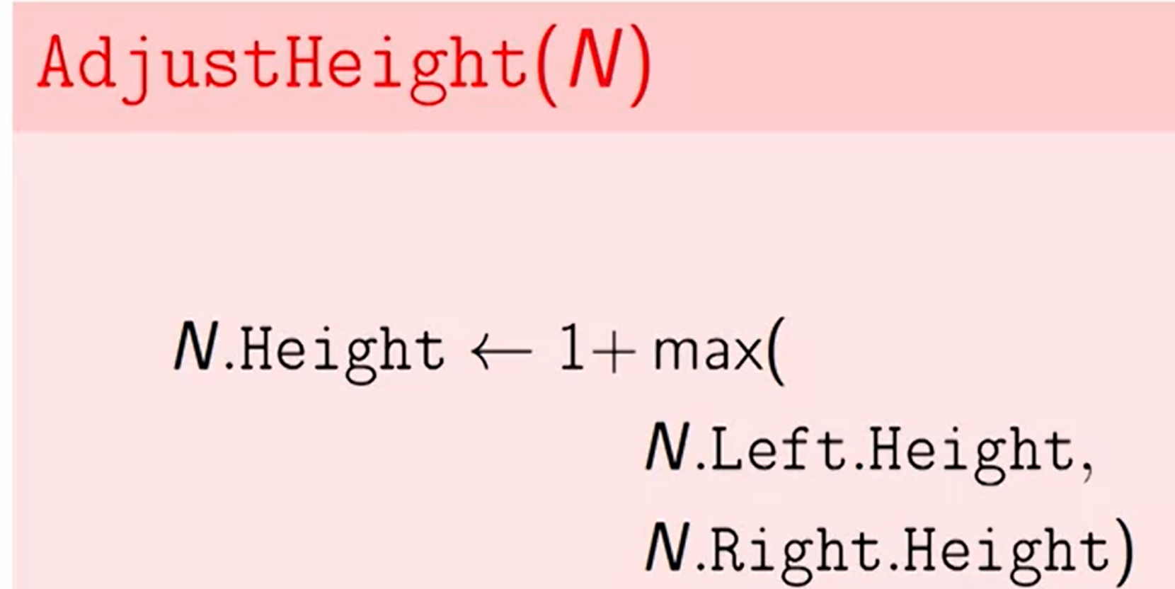

1. DeleteNode(value) – Tricky. Watch video again – Remove as last leaf is easy. Remove a node with one child is easy, just attach the child to the parent. In order to remove a node with two children, find the min in the right subtree of that node. That node will not have a left child. Replace the node value with the min node value and delete the one child min node. In other words, find the Next key using the next function above.
2. Right rotation  
   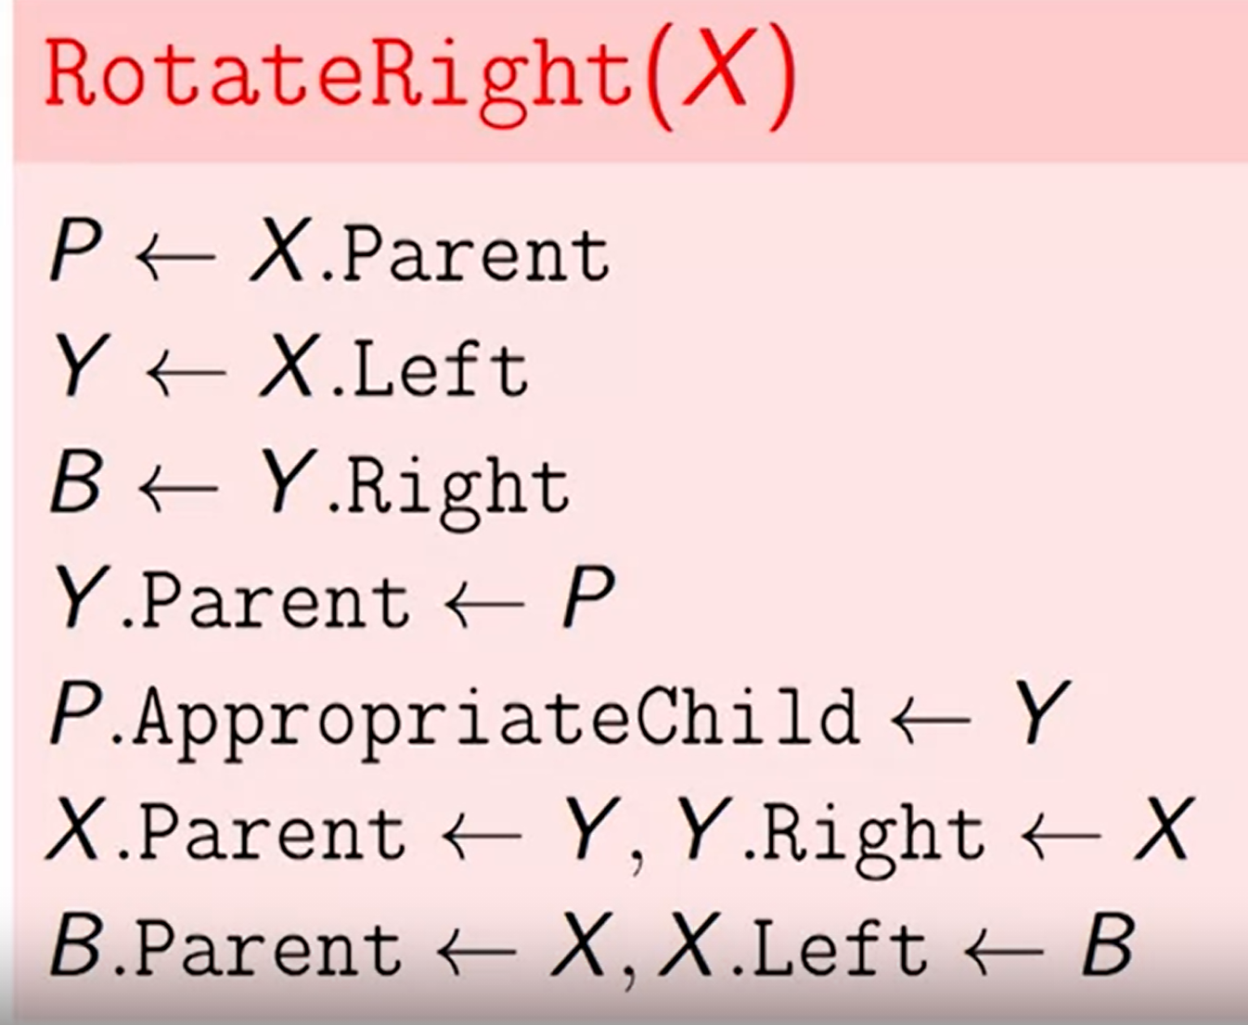
3. Learn more about AVL tree rotations specifically left right and right left rotation.
   1. 4 types of rotations https://www.geeksforgeeks.org/avl-tree-set-1-insertion/
   2. Left left
   3. Left right
   4. Right Right
   5. Right left

## Disjoint set – is in week 3 of data structure course – Finished in Javascript

A disjoint sets data structure contains multiple sets. Each set has unique elements and 1 element does not belong in another set meaning they are disjoint. A disjoint sets data structure supports the following operations

1. MakeSet(x) create a singleton set with element x
   1. Set the parent and rank arrays accordingly
2. Find(x) return ID of the element containing set
   1. If x and y are in same set, Find(x) = Find(y)  
      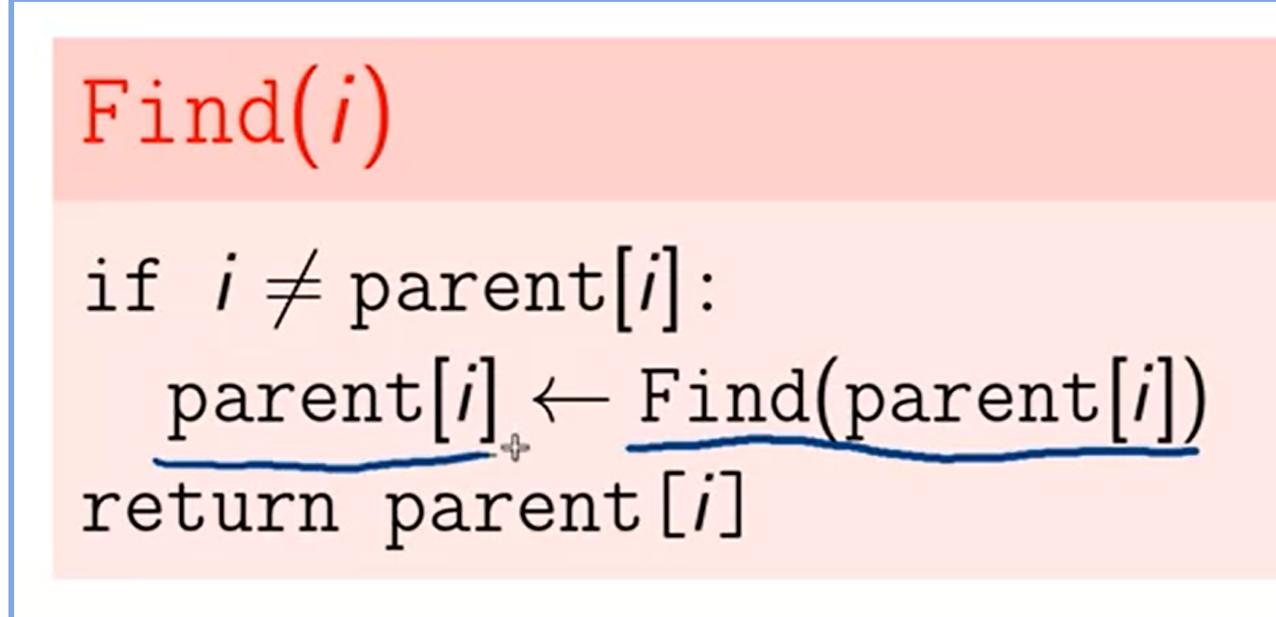
3. Union(x,y) – merges the set containing x and the set containing y  
   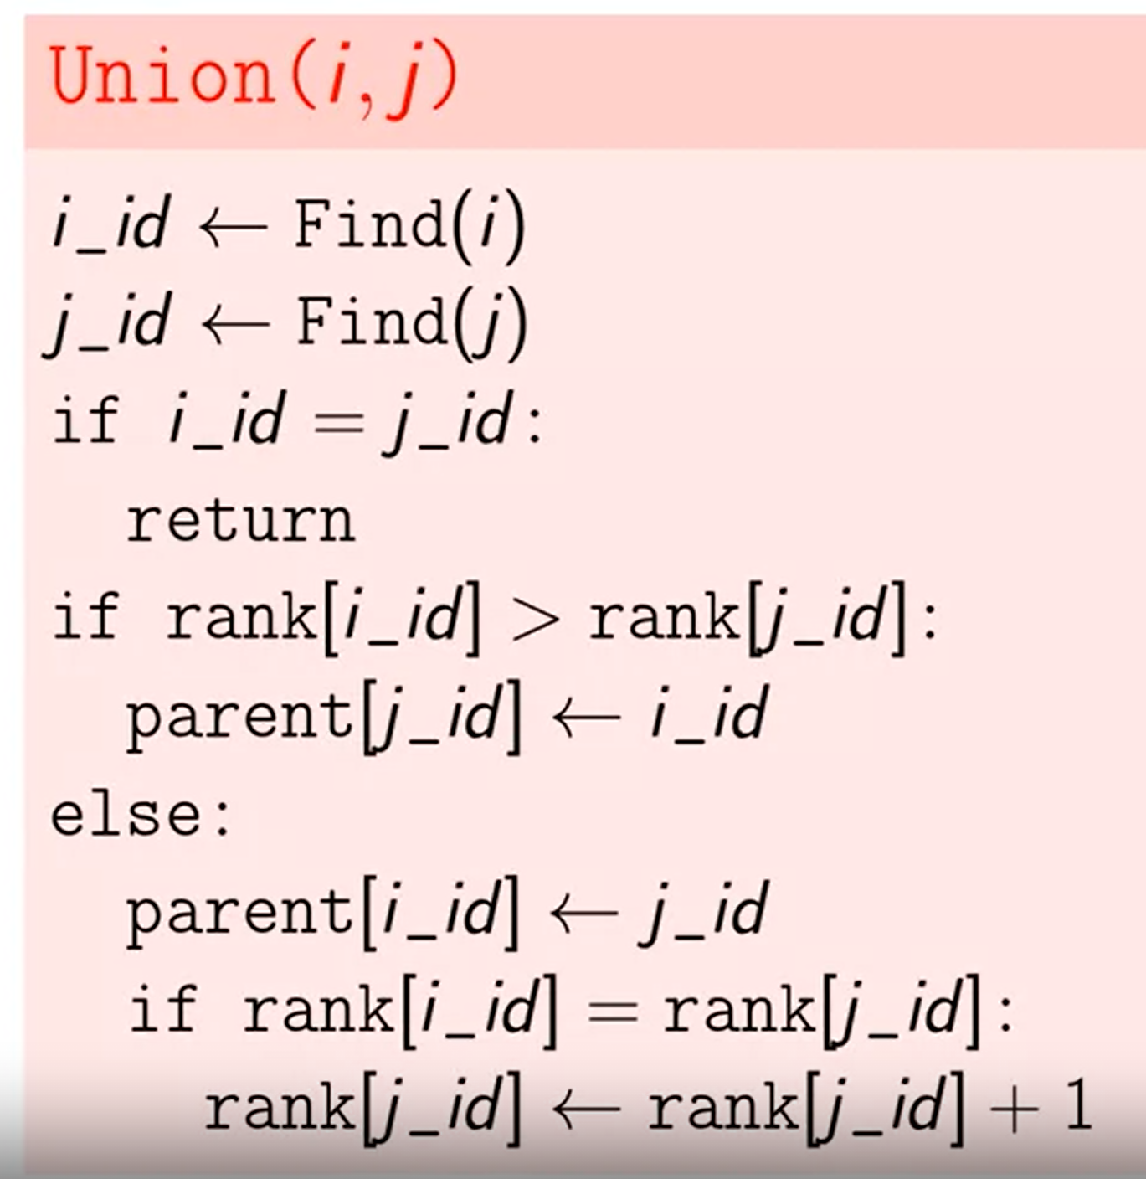
4. Using an array parent[i] where the ID of the root node will be the id of the set  
   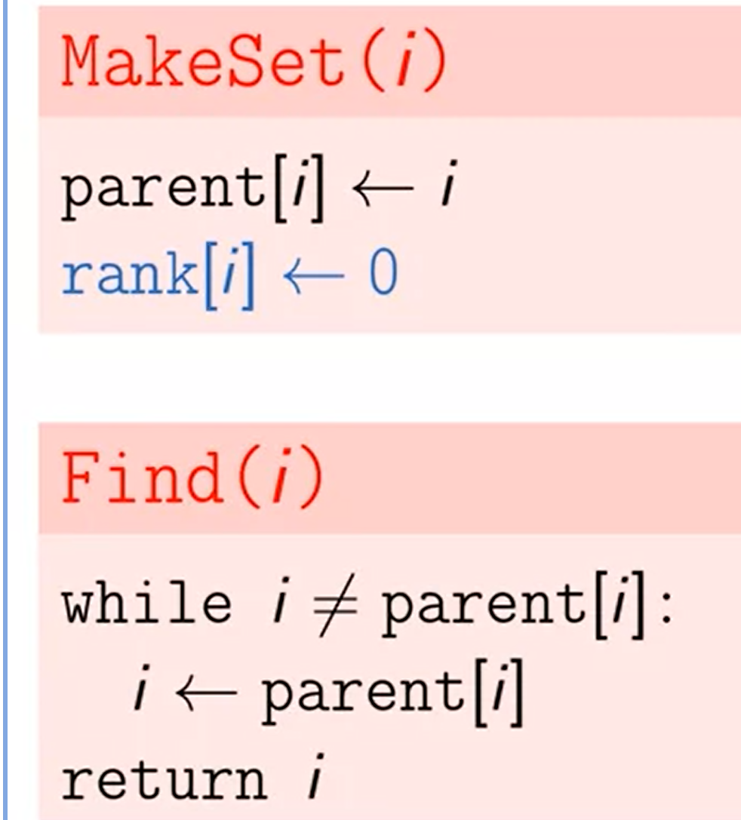
5. In order to perform a union, we hang tree under another tree. However, we also make sure we hang a short tree under the root of a tall tree.
6. We will keep the height of each tree rooted at I in an array rank[i]

## Hash Table

1. Key-value lookup
2. Key can be any data structure and value can be any data structure
3. A hash function takes in the key, converts it to an integer also called the hash code and then that hash code is converted into an index. The index is then used as an index for the array where the values are stored.
4. Its possible for key to hash to the same hash as another key. This is called a collision. A collision can be resolved by stroing the associated items in the index of the resultant array as a linked list. You store both the key and value ain the linked list.
5. Three methods
   1. HasKey(k) returns true or false based on whether the key exists
   2. Get(K) – Returns the value associated with that key or errors if there is no such value.
   3. Set(K,V) sets the key to the value.
   4. Use chaining to implement the hashmap
6. Select the appropriate has function

## Graph – Implemented in Python

1. Graphs represent connection between objects
2. Graph representation
   1. Edge List representation – Stored as a list of pair of verteces
   2. Adjacency matrix representation – 2 by 2 matrix
   3. Adjacency list (represented with a dict) is the most common representation
3. Should implement the following
   1. Is Edge – Takes two vertices and asks if there is an edge between them
   2. List Edges – Lists all the edges in the form of (V,V) pairs
      1. Pseudocode
         1. Exploredvertices = {} blank set
         2. vertexPairs = {} blank set
         3. For vertiex in self.graphdict.keys():
            1. If vertex not in exploredvertices:

Explore(vertex)

* + - * 1. Else:

Continue

* + - 1. Explore(vertx): pseudocode
         1. Exploredvertices.add(vertex)
         2. For vertex2 in self.graphdict[vertex]:

If vertex2 not in Exploredvertices:

Explore(vertex2)

Else:

vertexPairs.add(vertex,vertex2)

* 1. List Neighbor – Takes a vertex and lists all neighbors of that vertex
  2. Path(V21,v2) – Return true if there is a path from V1 to V2 so no need to explore other vertices
     1. Make sure that is V1 and V2 is already seen then
     2. Recursively call explore(V1) function and add it to the list of explored vertices. Once all vertices have been explored, check whether V1 and V2 are in that list.
     3. If a vertex has been explored then the algorithm should continue as there could be a circular reference.
     4. A sample graph  
        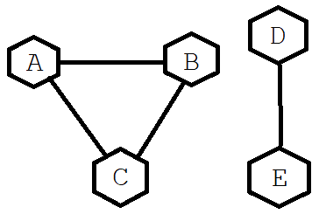
        1. A: [B,C]
        2. B:[A,C]
        3. C:[A,B]
        4. D:[E]
        5. E:[D]
     5. Explore(v1):
        1. If v1 in explored_vertices:
           1. Return
        2. Else:
           1. explored_vertices.add(v1)
           2. Previsit(v)
           3. vertices_to_explore = graphdict[V1]
           4. For vertex in vertices_to_explore:

Explore(vertex)

* + - * 1. PostVisit(V)
  1. ConnectedComponents() :Returns a list of sets that contains all islands in the graph
     1. For vertex in graphdict vertices:
        1. If vertex not in exploredvertices:
           1. Explore(vertex)
           2. Add explored vertices to list of sets
  2. AddVertex(v) adds a vertex to the list of vertices
  3. Add edge (v1,v2) adds and edge between vertex 1 and vertex 2

1. Continue from week1 connectivity
2. Consists of edges and vertices
3. Vertices are connected to each other with edges
4. Some graphs are directed, some are undirected
5. If two vertices have an edge connecting them, they are neighbors
6. Size of a graph is dependent on the number of edges and vertices
7. A path from one vertex to another is an important concept
8. Edges can have a weight on them such as a price or cost for taking that edge